**2016-09-02**

**2016年 全国统一考试诊断卷·天一信息卷（A）**

书面表达

假定你是高三学生李华，你的英国朋友Tom计划高中毕业后来中国留学，希望你给他介绍一下在人际交往中要注意的礼节方面的问题。内容包括：

1 首次见面 2 到家做客； 3 餐桌礼仪

注意：1 词数100左右；2 可适当增加细节，以使行文连贯；3 开头结尾已经给出，不计入总词数。

参考词汇：社交礼仪 social etiquette

Dear Tom,

I am glad to hear that you are coming to China for further study. ___

___________________________________________________________

Looking forward to your coming.

Yours sincerely,

Li Hua

etiquette [eti`keit] Un.

= courtesy U.n. 礼貌;殷切;好意

C.n. 谦恭的行为; 亲切的话语

at first sight

at table at the table

餐桌礼仪：

* 入座礼仪。
* 进餐礼仪。
* 给客人或长辈布菜。

Dear Tom,

I am glad to hear that you are coming to China for further study. Now, I’ll tell you some social etiquette you should pay attention to.

First, you are supposed to shake hands when you meet someone for the first time. Second, when you are invited to dinner in a Chinese family, you’d better arrive five minutes earlier or right on time. If you like, you can take some fruit or small gifts. In China, we use chopsticks instead of forks and knives. So don’t play with your chopsticks.

Chinese people are warm and friendly, I believe they won’t mind even if you do something improper. But just as the saying goes, “When in Rome, do as the Romans do.” If you do like this, you will have a nice time in China.

Looking forwards to your coming.

Yours sincerely,

Li Hua

Writing: 3C

Correct Clear Concise

Class 1

Beginning

I am glad to hear that you are coming to China for further study. __________________

1. It is my pleasure to introduce Chinese social etiquette to you.
2. You having already asked some questions on the manners in China, I am writing this letter to help you.
3. Here are some tips about social etiquette you should know.
4. In order to help you adjust to China, I will give you some suggestions below.
5. China is a country which attaches great importance to social etiquette. Therefore, it is essential for you to learn about some.
6. I’m writing to introduce some social etiquette, without which you may think it difficult to be involved in social communication.
7. It is high time that you know some social etiquette in China.
8. It is necessary that you should know about some social etiquette.
9. So for your further development, I would teach you some things about social etiquette.
10. So I’m writing this letter to tell you some important social etiquette in China.
11. That Chinese are more conservative than foreigners like you may be the most approximate difference you will handle.
12. Bound to adjust yourself to Chinese culture, you have asked that if I can pass on experience relevant to social etiquette. What I want to tell you in brief is about three aspects of the cultural etiquette.

Supporting

1. When you first meet someone, it is better to say “Hello” to him than give him a hug.
2. When you see someone first, you should be polite and great to him warmly.
3. When meeting others for the first time, shaking hands with them gently and smiling friendly would be recommended, while kiss or hug seems strange to our Chinese.
4. Second, to give a genty impression to the host, you should pay attention to have a suitable behavior if you were a guest.

Ending

1. I hope that you can adapt the life in China.
2. I believe that you will have a wonderful time in China.
3. I sincerely hope that this letter could help you.
4. I would be happy if you find my information useful.
5. Following my advice, you will be accustomed to Chinese life rapidly.
6. I would appreciate it if you could reply to me soon.
7. Whoever would be left a good impression on if you were to follow the social etiquette above.

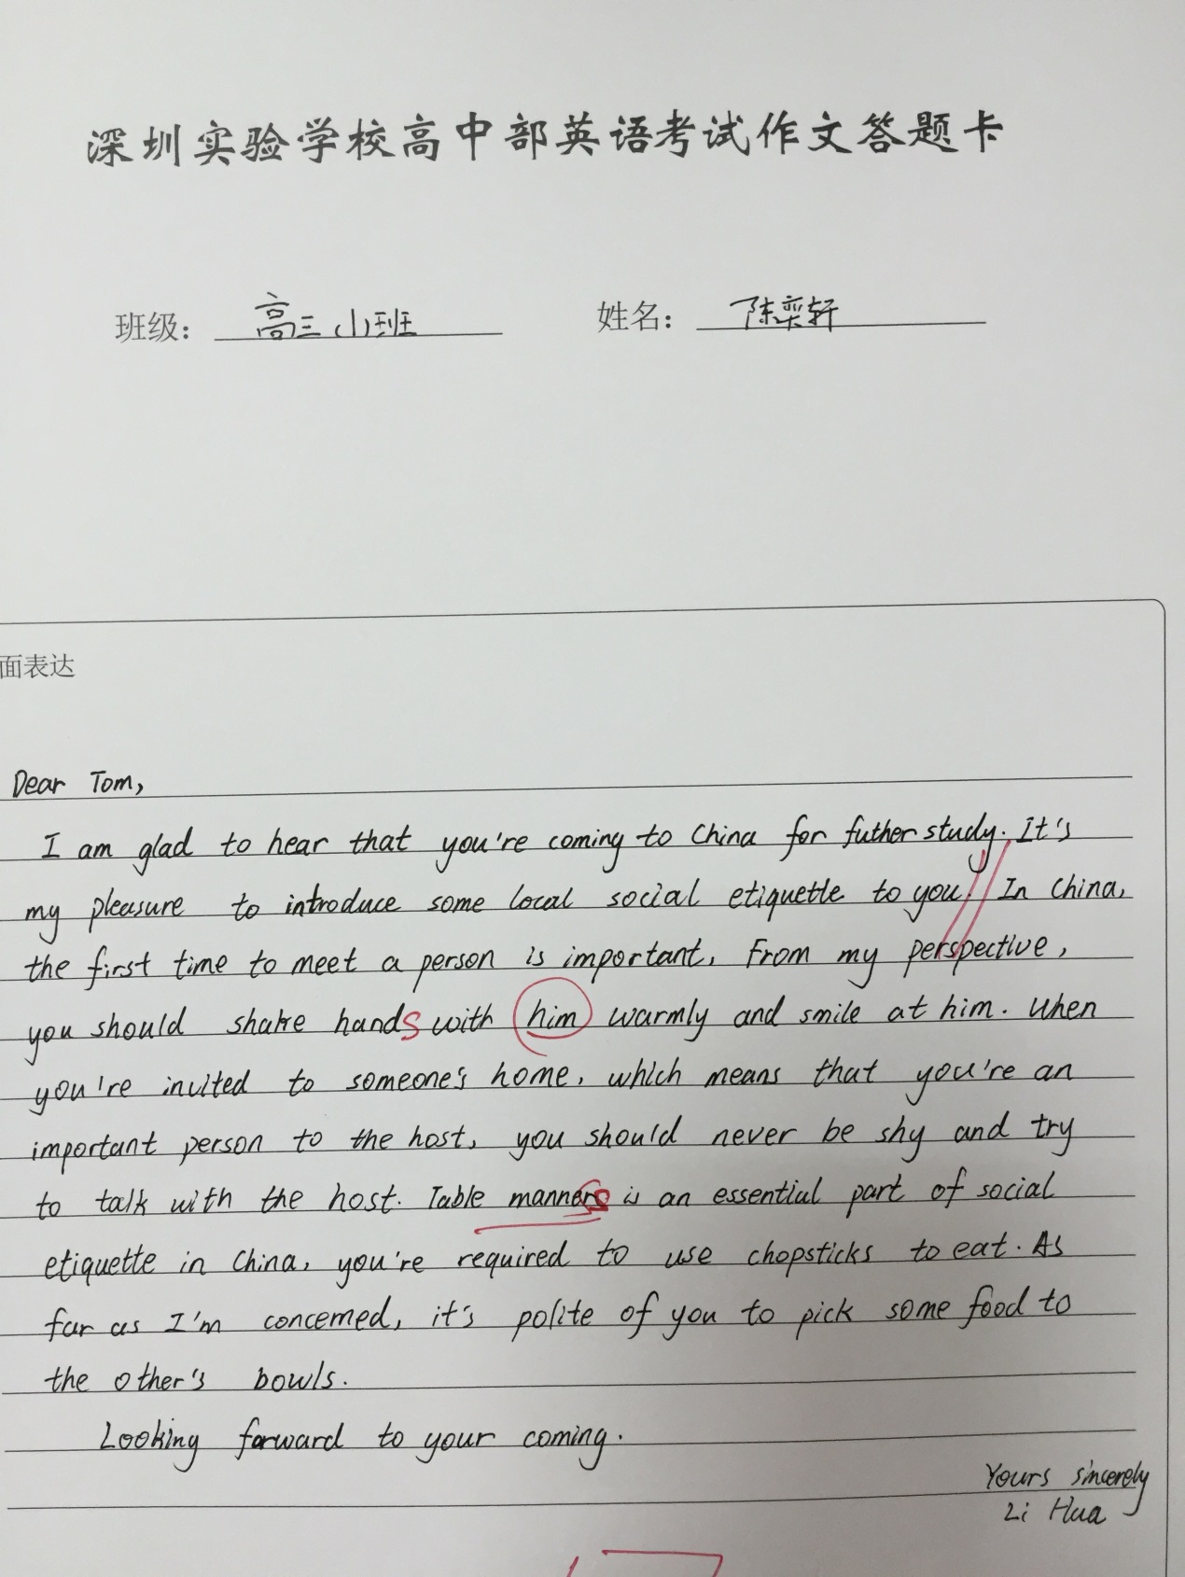

Class 2

Beginning

I am glad to hear that you are coming to China for further study. __________________

1 I think it’s high time for you to learn about our social etiquette.

2 Now I’m writing to inform you about some social etiquette in China in order to help you assimilate into your new life with greater ease. As for an exchange student like you, learning some necessary social etiquette is greatly imperative, so here I list some situations you may face and need to pay attention to.

3 However, before your arrival, it is necessary for you to learn some social etiquette of China, which will absolutely make a difference in your daily life.

4 It is my pleasure to introduce you some points concerning social etiquette, with which I hope you will have more ease to adapt yourself to the new circumstance.

Supporting

First, the first meeting with someone is significant, at which time you leave a fundamental impression on some one that may be difficult to change. So you should shake hands with other tightly as routine and use term respect while performing gentely and charmfully.

Ending

There is no doubt that taking those above into account will do you credit.

I hope the above will be helpful to you.

I hope these tips will help you in the future.

I hope you will find these suggestions useful.

Only by remembering basic social etiquette can you get along with Chinese people much easier.

If there is anything else I can help, please don’t hesitate to ask me.

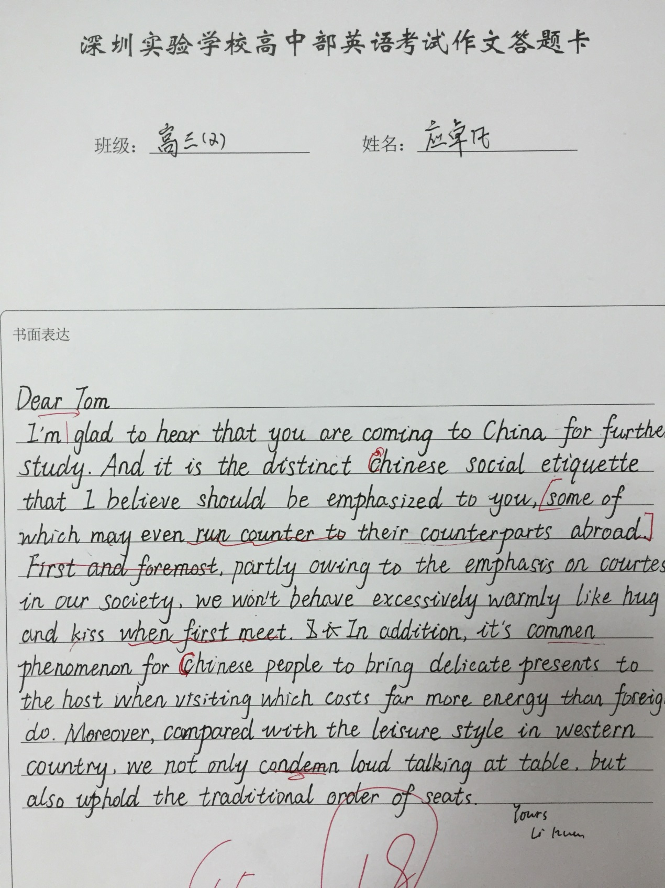

Students’ Paper

(1)

Dear Tom,

I’m glad to hear that you are coming to China for further study. And it is the distinct Chinese social etiquette that I believe should be emphasized to you, some of which may even run counter to their counterparts abroad. First and foremost, partly owing to the emphasis on courtesy in our society, we won’t behave excessively warmly like hug and kiss when first meet. In addition, it’s commen phenomenon for Chinese people to bring delicate presents to the host when visiting which costs far more energy than foreigners do. Moreover, compared with the leisure style in western country, we not only condemn loud talking at table, but also uphold the traditional order of seats.

Yours,

Li Hua

(2)

Dear Tom,

I’m glad to hear that you are coming to China for further study. As you know, it’s important to know about Chinese social etiquette before studying in China. Here are my suggestions.

Firstly, what you should pay attention to is how to communicate with a stranger. Most of Chinese are conservative, so you’d better shake hands but not kiss or hug when you meet someone for the first time. In addition, you should take off your shoes if you enter the host’s house. You must obey the host, which can leave a good impression on the host. When having dinner, remember that no until the host starts to eat should you begin to use chopsticks.

These are some key points. I hope that these suggestions are useful and you will enjoy Chinese life-style in the future.